

**LAB # 2**

**SUBMITTED BY:** Kulsoom Khurshid

**REGISTRATION #:** SP20-BCS-044

**COURSE:** Artificial Intelligence

**SUBMITTED TO:** Ma’am Shahela Saif

**Activity#1**

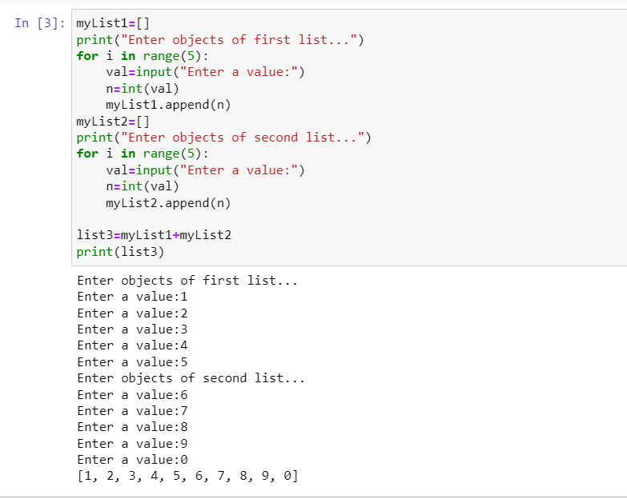

**Activity#2**

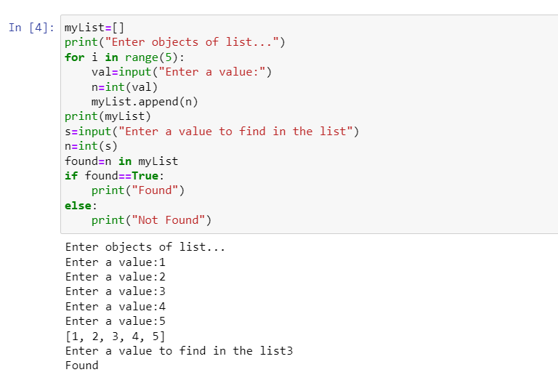

**Activity#3**

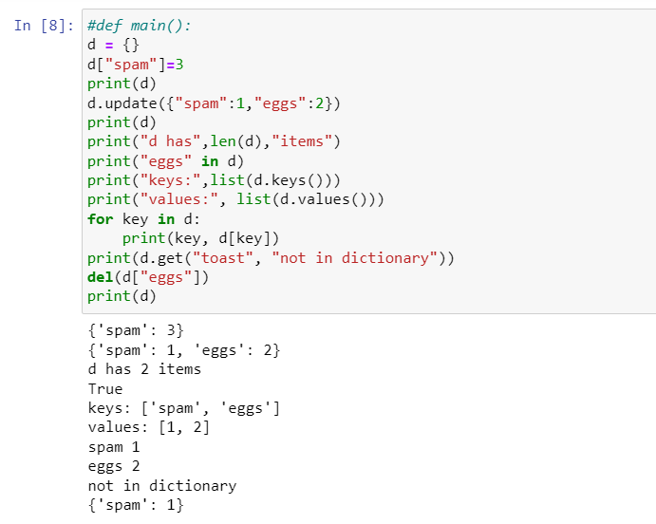

**Activity#4**

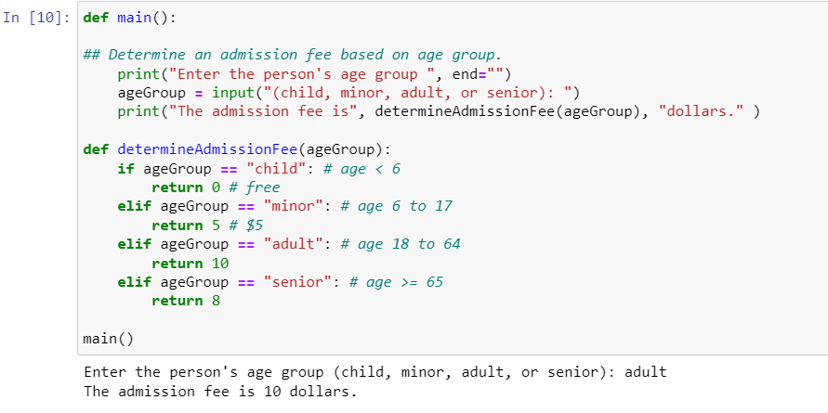

**GRADED ACTIVITIES**

**Activity#1**

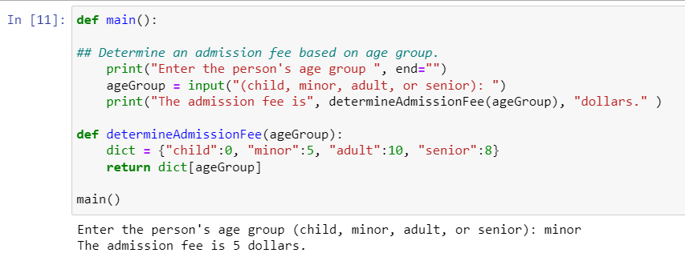

**Activity#2**

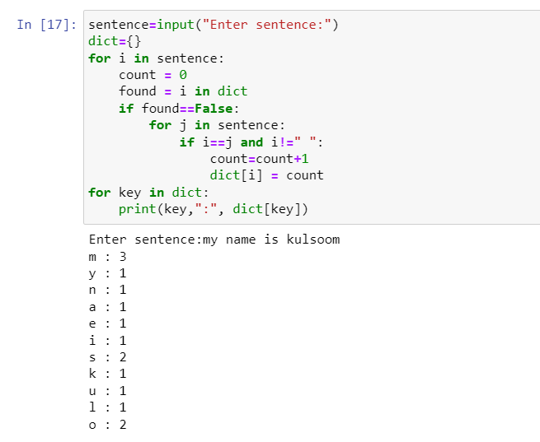

**Activity#3**

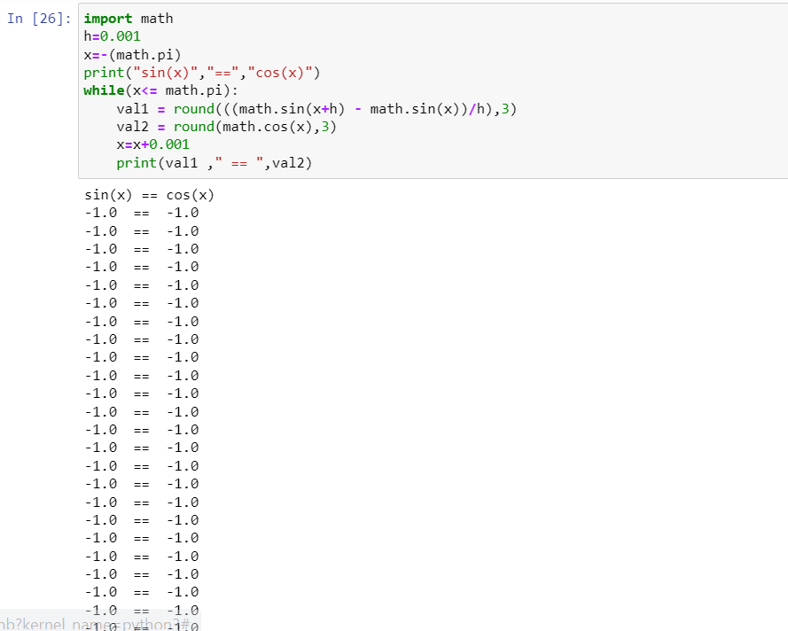

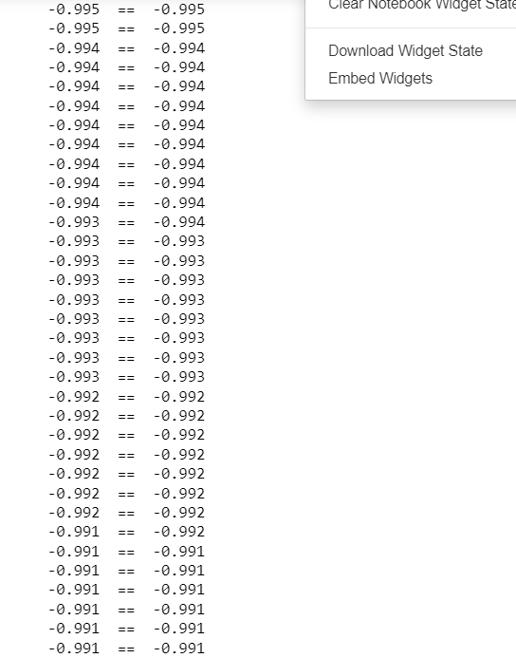

As we increment the value of x by 0.01 we will have lesser values that will be equal for cos(x) and sin(x) than x value incremented by 0.001. Similarly, if x value incremented by 0.1 we will have lesser values that will be equal for cos(x) and sin(x) than x value incremented by 0.01.